EXPERIMENT 2

AIM:
To study absorption in matter by γ-ray source:
- To find attenuation constant for Aluminium.
- To verify inverse square law of radiation.

THEORY:
A Geiger-Muller counter has 2 parts – GM Tube and Electronic Counter

1) GM Tube:
The GM Tube has the following setup:
- A cylindrical chamber with the chamber walls as the cathode (-ve potential)
- A wire in the center of the chamber as the anode (+ve potential)
- An inert gas (like Argon) filled at low pressure
- Some halogen/alcohol/organic vapors mixed with the gas
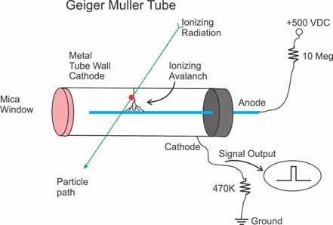
The voltage applied between the cathode and anode (typically hundreds of volts) produces a strong radial electric field inside the tube.
Figure 1: Structure of a GM Tube
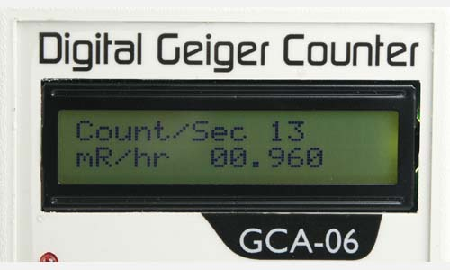
2) Electronic Counter:
It has the following setup:
- Pre-amplifier/Amplifier
- Discriminator
- Counter
- Display
- Audio Indicator
Figure 2: Electronic Counter

3) Working:
- When a particle enters the chamber, it strikes the gas and emits some electrons.
- Due to the strong electric field, the electrons are accelerated towards the anode wire and knock off more electrons from the gaseous atoms in their path. This is called an Avalanche or Townsend discharge. It creates approximately 10⁹ ion-electron pairs.
- As this avalanche reaches the wire, the counter measures this brief pulse of current (some nanoseconds wide)
- Since the pulse is a weak signal, the pre-amplifier/amplifier boosts it to keep it distinct from the surrounding noise.
- The Amplifier also shapes the signal into a standard digital-like pulse to ensure that all signals look the same, no matter how strong the Avalanche was. Else, a strong Avalanche would be counted as 2 pulses and a weak Avalanche would not be counted.
- The Discriminator filters out the surrounding noise by counting signals only above a specific voltage.
- The Counter is incremented each time a valid pulse is registered. It typically counts pulses per second (CPS) or pulses per minute (CPM).
- The Display shows the reading on an LCD screen or produces audible clicks each time a pulse is generated.
Inert gas is used inside the chamber as it does not react with the chamber walls and corrode them. It also does not recapture electrons to form negative ions; thus, the avalanche process is efficient.

4) Dead Time:
It is the short time after each pulse during which the counter cannot measure any radiation. This happens due to the following:
- After a pulse, there are a lot of positively charged ions left in the chamber.
- If they are left, they will strike other gaseous atoms and eject electrons, once again starting an Avalanche. Thus, a single particle would trigger multiple avalanches and be overcounted.
- To avoid this, some halogen/alcohol (quencher) is added in the chamber with the gas.
- The positively charged ions strike the quencher and excite the halogen atoms. This breaks the bonds of the molecule instead of releasing electrons.

Cl₂ Cl + Cl

- The single halogen atoms generated then combine with one another, releasing energy harmlessly (non-ionising radiation).
Cl + Cl Cl₂
- This way, the avalanche is stopped and the tube is ready for the next reading.
This entire process takes a certain amount of time, known as the dead time. It can vary from few $μs$ to few milliseconds.

5) Absorption of Gamma Rays:
The gamma ray can be absorbed by a given substance by the following processes:
- The photoelectric effect
- Compton scattering
- Pair Production
In all three of these processes the gamma ray is either scattered away from the incident direction or completely absorbed. That is, a detector is placed on the opposite side of the absorber, along the incident direction of a beam of gamma rays and only those gamma rays which did not interact with the absorber will be detected. Whether the gamma ray will interact with matter by any of the above-mentioned processes is probabilistic and thus the gamma ray absorption is a random process. It is not possible to say whether a particular gamma ray will interact with the absorber or pass through unaffected.

6) Mass Attenuation Coefficient:
It tells how strongly a material absorbs or scatters radiation, normalized by density. It is written as:
$$μ_{m}=\frac{μ}{ρ}$$
$μ$ = linear attenuation coefficient – how quickly radiation decreases per unit thickness of material (measured in cm⁻¹)
$ρ$ = density of the material (gm/cm³)

$μ_{m}$ has units of cm²/g.
It’s a way to compare different materials independent of density.
- A high $μ_{m}$ means the material is very effective at blocking radiation per gram.
- A low $μ_{m}$​ means it’s relatively transparent to radiation.
When radiation of intensity I₀ passes through thickness x of a material, the intensity after is:
I(x) = I₀$ⅇ^{-μx}$
N(x) = N₀$ⅇ^{-μx}$

7) Inverse Square Law:
In the absence of aluminium plates, gamma radiation obeys an inverse square law in air since absorption is negligible. Radiation spreads out over an increasing sphere.
Area of a sphere = 4πr²
As r gets larger, intensity will decrease as $\frac{1}{r^{2}}$. The effect of absorption by the air will be relatively small.

OBSERVATIONS:
1) For attenuation constant of Aluminium:
Gamma-ray source: Na²²
Table 1: Background Radiation
SL. No. | Count (for 10 mins) | Count/s | Average count/s
1 | 186 | 0.31 | 0.321
2 | 171 | 0.285
3 | 220 | 0.367

Average background radiation = 0.321 counts/s

Table 2: Measuring radiation with thickness
SL. No. | Thickness (mm) | Counts/30 s | Average Count | Corrected Count | ln(Corrected Count)
1 | 1.04 | 20 | 17.8 | 8.17 | 2.1
 |  | 18
 |  | 18
 |  | 16
 |  | 17
2 | 2.04 | 15 | 17.2 | 7.57 | 2.024
 |  | 18
 |  | 18
 |  | 17
 |  | 18
3 | 3.05 | 18 | 16.6 | 6.97 | 1.942
 |  | 15
 |  | 16
 |  | 16
 |  | 18
4 | 4.2 | 17 | 16.4 | 6.77 | 1.913
 |  | 16
 |  | 18
 |  | 15
 |  | 16
5 | 5.21 | 17 | 15.4 | 5.77 | 1.753
 |  | 14
 |  | 16
 |  | 15
 |  | 15
6 | 9.66 | 14 | 14 | 4.37 | 1.475
 |  | 13
 |  | 17
 |  | 15
 |  | 11
7 | 14.85 | 12 | 13.4 | 3.77 | 1.327
 |  | 12
 |  | 15
 |  | 14
 |  | 14
8 | 24.54 | 6 | 12 | 2.37 | 0.863
 |  | 16
 |  | 12
 |  | 13
 |  | 13
9 | 34.31 | 10 | 11.4 | 1.77 | 0.571
 |  | 11
 |  | 14
 |  | 10
 |  | 12
10 | 38.99 | 10 | 11 | 1.37 | 0.315
 |  | 13
 |  | 12
 |  | 11
 |  | 9

2) For Inverse Square Law:
Table 3: Inverse Square Law
SL. No. | Distance (r) (in cm) | Counts | Average Count | Corrected Count | ln(r) | ln(Corrected Count)
1 | 12 | 36 | 32.33 | 22.7 | 2.485 | 3.122
 |  | 26
 |  | 35
2 | 11.5 | 28 | 32.33 | 22.7 | 2.442 | 3.122
 |  | 35
 |  | 34
3 | 11 | 51 | 39.67 | 30.04 | 2.398 | 3.403
 |  | 31
 |  | 37
4 | 10.5 | 35 | 37.67 | 28.04 | 2.351 | 3.334
 |  | 38
 |  | 40
5 | 10 | 42 | 45 | 35.37 | 2.303 | 3.566
 |  | 46
 |  | 47
6 | 9.5 | 49 | 50 | 40.37 | 2.251 | 3.698
 |  | 36
 |  | 65
7 | 9 | 52 | 50.33 | 40.7 | 2.197 | 3.706
 |  | 49
 |  | 50
8 | 8.5 | 61 | 58.33 | 48.7 | 2.14 | 3.886
 |  | 53
 |  | 61
9 | 8 | 64 | 71.67 | 62.04 | 2.079 | 4.128
 |  | 70
 |  | 81
10 | 7.5 | 77 | 67 | 57.37 | 2.015 | 4.05
 |  | 64
 |  | 60
11 | 7 | 76 | 84 | 74.37 | 1.946 | 4.309
 |  | 78
 |  | 98
12 | 6.5 | 101 | 102.33 | 92.7 | 1.872 | 4.529
 |  | 104
 |  | 102
13 | 6 | 127 | 119.67 | 110.04 | 1.792 | 4.701
 |  | 133
 |  | 99
14 | 5.5 | 136 | 126.67 | 117.04 | 1.705 | 4.763
 |  | 130
 |  | 114
15 | 5 | 136 | 150.33 | 140.7 | 1.609 | 4.947
 |  | 166
 |  | 149
16 | 4.5 | 199 | 186.33 | 176.7 | 1.504 | 5.174
 |  | 189
 |  | 171
17 | 4 | 240 | 253.33 | 243.7 | 1.386 | 5.496
 |  | 258
 |  | 262
18 | 3.5 | 267 | 286.67 | 277.04 | 1.253 | 5.624
 |  | 303
 |  | 290
19 | 3 | 335 | 364.67 | 355.04 | 1.099 | 5.872
 |  | 375
 |  | 384
20 | 2.5 | 514 | 500.67 | 491.04 | 0.916 | 6.197
 |  | 489
 |  | 499
21 | 2 | 659 | 682 | 672.37 | 0.693 | 6.511
 |  | 683
 |  | 704
22 | 1.5 | 930 | 967.33 | 957.7 | 0.405 | 6.865
 |  | 1026
 |  | 946

CALCULATIONS:
Attenuation constant
The number intensity of radiation varies with thickness as:
N(x) = N₀$ⅇ^{-μx}$
=> ln N = ln N₀ – $μx$
A plot of ln(N) v/s thickness(x) gives -$μ$ as the slope.
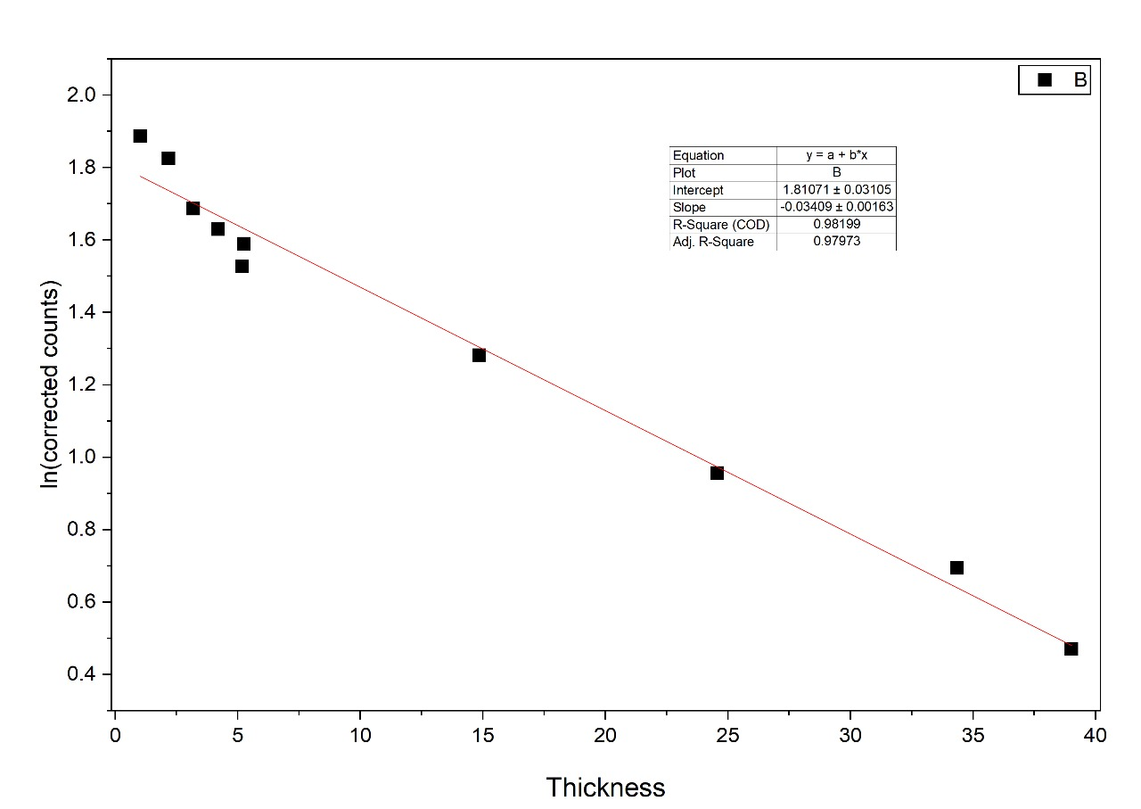
Figure 3: Plot of ln (counts) v/s thickness
From the graph, the slope comes out to be -0.034. Hence, attenuation constant of aluminium is 0.034 mm⁻¹.
Inverse Square Law
Radiation count (N) varies with distance as $\frac{1}{r^{2}}$.
N(r) = $\frac{k}{r^{2}}$
=> ln N = -2 ln r + ln k
A plot between ln(counts) v/s ln(r) should yield a slope of -2.
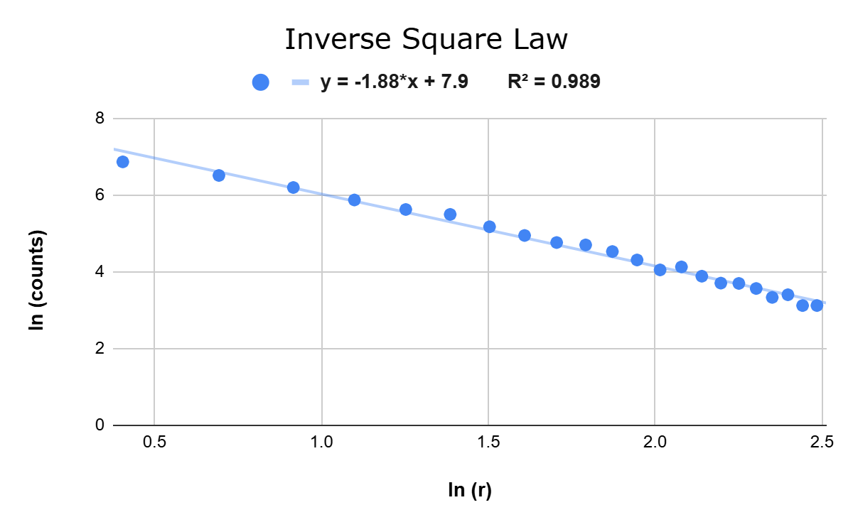
Figure 4: PLot of ln r v/s ln counts
From the graph, the slope comes out to be -1.88, which is close to -2, verifying the inverse square law.

SOURCES OF ERROR:
- Statistical Error: Radioactive decay is a random process. The count measured fluctuates naturally, following Poisson statistics. The uncertainty is $\sqrt{N}$ for N counts.
- Background Radiation: Cosmic rays and other natural sources contribute extra radiation. If it is not subtracted properly, the results may shift.
- Dead Time: At high radiation rates, the GM counter would undercount the number of particles.
- Alignment: The source and the detector may not be aligned in a straight line. If the detector is not aligned at the right distance, the inverse-square law would not hold.

CONCLUSION:
- The linear attenuation constant of Aluminium comes out to be 0.034$±$0.002 mm⁻¹.
- The inverse-square law of radiation is verified.

